**HOW TO RECORD**

**This document tells you how to register all sensor nodes to motherboard.**

**STEP 1:**

Be sure all nodes have a battery, motherboard is working and sensors are not moving. After that you have to click sensor nodes blue button one time and be sure there is enough distance between you and sensor. If any sensor moved after this process, the sensor may not work properly. If sensor is placed to under seat already you dont worry about to moving. After any process on the sensor you have to reset sensor node this way.

**STEP 2:**

Press to blue button on the motherboard during 4 second. You will see blue led blinks during this process. This mean motherboard delete all database. After this process the screen show empty seats.

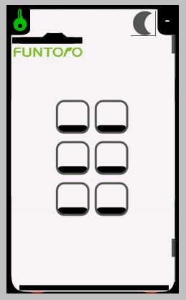

**STEP 3:**

Press blue button on the motherboard just one time. Be sure blue led is lighting. During this process don't touch any sensors. Now the screen shows you record mode page.

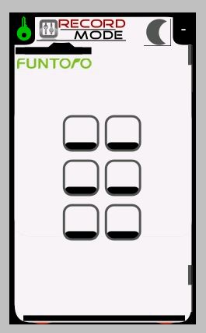

**STEP 4:**

Touch first seat sensor you want to see on the screen right side one. If the sensor node have two sensor pads, motherboard will automatically save the other one. You don't need to touch other sensor. Please repeat this process on other seats too.

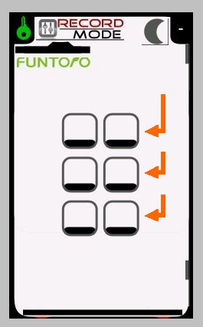

When all process done the screen looks like below.

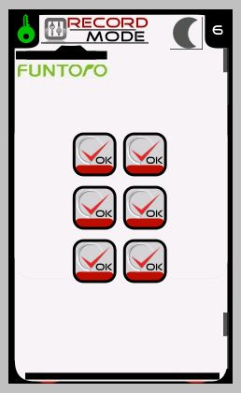

**STEP 5:**

After all nodes recorded to motherboard, click the blue button on the motherboard just one time. Be sure the blue led is off. The screen will show you this page.

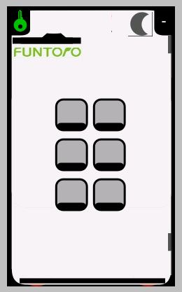

Note: Sensor node battery is very sensitive. If you are testind nodes on the floor please be sure battery looks on top not bottom. If you are testing nodes under the seats please be sure the battery looks to opposite to seat side(bottom side).

Be sure all sensor pads are not close any metal objects.

Be sure any sensor cable have not to be crose each other. It has to be separately.